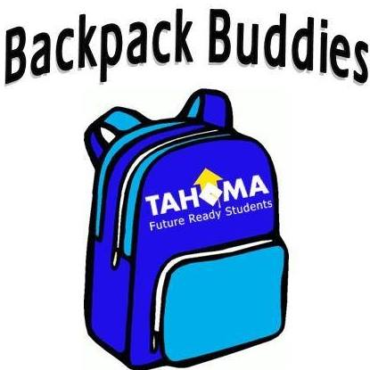

**Sponsorship Program 2017-2018**

We are looking for individuals and businesses who would like to support Backpack Buddies of Maple Valley. Backpack Buddies is a program in the Tahoma School District that serves kids who are in need of food over the weekends. We buy, pack and deliver bags of food to the schools each week. We are a non-profit organization that is fully dependent on community contributions. Please look below to see what level of sponsorship you would like to donate at.

**White** Sponsorship (1 kid for 1 month) $ 24.00

**Black** Sponsorship (1 kid for 1 year) $ 210.00

**Blue** Sponsorship (1 school for ½ year) $ 918.00

**Gold** Sponsorship (1 school for 1 year) $ 1,890.00

Businesses that choose to support us through a Blue and Gold sponsorships will be recognized on our website. Individuals who choose to support a Black sponsorship or above will also have this opportunity.

Thank you for your donation our pending tax id# is 82-2235427. Make checks payable to Backpack Buddies of Maple Valley. Mail checks to 20920 253rd Ave SE, Maple Valley, WA 98038. If you have any questions or comments please contact Mindy Gamble (President) at 206-714-4734.

*Numbers are based on bags costing $6.00 and the average amount of students being 9 per school (2016-17 numbers).